**U.S. Department of Energy (DOE)  
Clean Energy to Communities (C2C) Program**

Summary of Technical Assistance (TA) Support

|  |
| --- |
| Marker with solid fill |
| Icon  Description automatically generatedBuildings |
| Icon  Description automatically generatedClean Power |
| Climate Mitigation and Resilience |
| Cross-Sectoral Justice |
| A picture containing text, clipart  Description automatically generatedJobs and Economic Development |
| Icon  Description automatically generatedMobility |

**Highland Park, Michigan**

TA Scope

From April through July 2023, the National Renewable Energy Laboratory (NREL) provided technical assistance to the City of Highland Park, Michigan, to support the city’s clean energy development policies. NREL conducted content analysis, exploring the city’s existing zoning code for opportunities to create a more enabling environment for adopting renewable energy, resilience, and electrification technologies. Topics explored include provisions for electric vehicle (EV) parking requirements in new development; standards for EV charging stations, signage, and striping; and permitting and review processes for EV charging stations, solar photovoltaics and solar thermal, solar streetlights, geothermal heat pumps, battery electric storage systems, microgrids, and agrivoltaics.

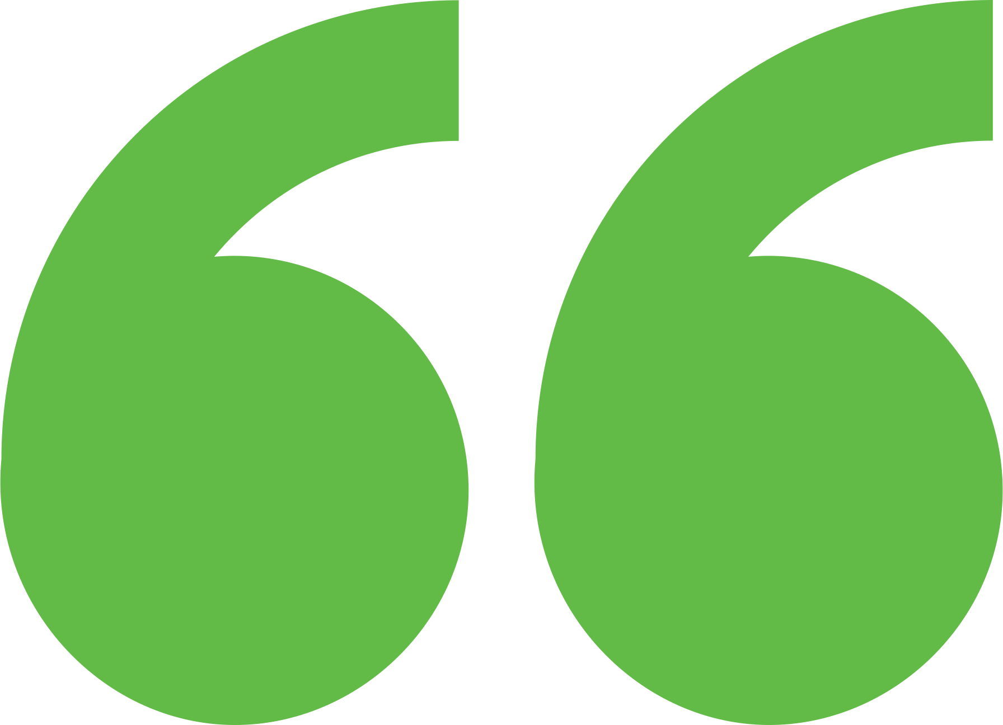 Impact

The technical assistance team provided a light review of targeted municipal code sections with considerations for strengthening them, drawing from regional best practice literature. It provided examples of model code language from reliable sources and other communities. The team also generated a list of policy gaps and opportunities the city could explore to promote clean energy development with clear standards and guidelines.

Background

**Background**

Ann Arbor is a city of approximately 122,000 people located in southeast Michigan. The city and its residents are leaders in sustainability and climate action. Their A2ZERO Climate Action Plan outlines their just transition pathway to community-wide carbon neutrality by 2030. With equity as a focus, they are implementing strategies to improve home energy efficiency (EE) and electrify appliances. Toward this, the city wants to explore community geothermal heating and cooling to serve a variety of building types including rental and affordable housing. The city has applied to DOE’s Geothermal Heating and Cooling Design and Deployment program and garnered the support of City Council to pursue these projects, but they need to understand the concept’s feasibility in order to make a “go, no-go” decision.

The City of Highland Park—known as the “birthplace of the Model T”—is a resilient community, despite economic collapse, redlining, and historic disinvestment in public infrastructure. This has led to low incomes, racial segregation, housing and utility burdens, and environmental justice issues. Despite economic collapse, a coalition of community members, activists, and city representatives envision a clean, efficient, and resilient energy future for all Highland Parkers while improving energy affordability, increasing community climate resilience, empowering the local economy, and improving the health and wellness of residents. They have been working toward these goals with NREL through Communities LEAP (Local Energy Action Program) since June 2022. The coalition realizes that to transition to a more affordable and clean energy system, policies, regulations, and processes must be in place, and in alignment, to create an enabling environment. The city’s contracted engineer applied to Expert Match to understand options to improve their zoning code such that clean energy technologies may be permitted, procured, and implemented with consistency, thoughtfulness, and speed.

Expert Match Team

**Chrissy Scarpitti**  
Community Lead, Main Expert Match Point of Contact, NREL

**Megan Day**  
Energy Planner, Local Policy Analysis Expert, NREL

**Sika Gadzanku**  
C2C Expert Match Program Manager, NREL

Community Team

**Eric Geerlings**  
Renewable Energy Project Manager, Metro Consulting Associates

For more information, visit:  
**energy.gov/eere/clean-energy-communities-program**

August 2024